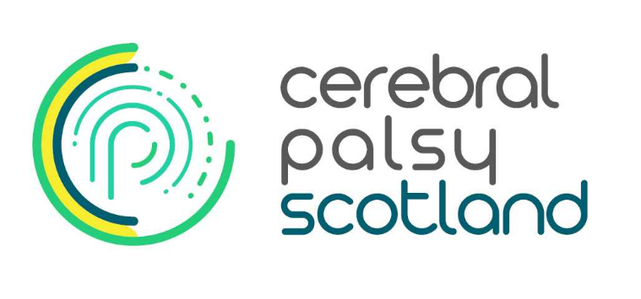
Referral to Cerebral Palsy Scotland
Please tick mailing preference: post ☐ email ☐
Date of referral:

Client/Child’s name:

Client/Child’s date of birth:

Name of next of kin, parent or carer:

Address:

Telephone Number:
Email address:
Diagnosis & cerebral palsy classification (if known):

Name of person referring:

Profession of person referring:
(if applicable)
Work address, telephone number & email address of
person referring if different from client:
Allied health professionals who are involved with the client (PT, OT, S&LT) |  | Physiotherapist Name:  Address  Telephone:  Email:  Occupational Therapist Name:  Address:  Telephone:  Email:  Speech and Language Therapist Name:  Address:  Telephone:  Email:
Client/Child’s Health Board

Client/Child’s Local Authority

A brief medical history of the client and update on current medical & physical status (including any previous or planned surgeries or other medical interventions):

Reason for referral:

Where did you hear about us?
Local Health Board | Contact details: (if applicable)
Local Authority | Contact Name:  Contact telephone number:  Contact Address  Contact email:

Referral should be addressed to:
Cerebral Palsy Scotland
Bradbury House
10 High Craighall Road
Glasgow
G4 9UD
Or email: info@cpscot.org.uk
What to expect after the referral has been received by Cerebral Palsy Scotland
- It may take up to 3 weeks before we contact you after receiving the initial referral form, please contact us after this time if you haven’t heard from us.

- We may contact allied health professionals who work with the client to obtain information on the therapy input the client is currently receiving and what they want us to focus on if they are accepted for therapy at Cerebral Palsy Scotland.

- We will also contact parents or carers (if applicable), to obtain their view on the client’s current status and to determine their expectations of therapy at Cerebral Palsy Scotland.
- We aim for clients to be seen within 3 months of the referral being received.
- New clients will be seen for an initial assessment by our multidisciplinary team prior to offering a therapy.
- Following the initial assessment, recommendations will be provided for therapy, together with an estimated total cost or an indication if funding can be provided.

